# Stock market analysis

Name: Mohammed Nawaz Shariff

Department :MCA (VTU) Semester:Third

USN: 1BO23MC023

**INDEX**

* Title Name
* Outline
* Abstract
* Problem Statement
* Proposed Solution
* Short Video
* Implementation
* Output Screenshots
* References

**Abstract**:

This study explores the dynamics of stock market behavior, focusing on the identification of key trends, market drivers, and predictive modeling techniques. By examining historical data from major stock indices, the research highlights the role of macroeconomic indicators, investor sentiment, and geopolitical events in influencing stock prices. Statistical tools, such as time series analysis and machine learning algorithms, are employed to predict short- term and long-term market movements. The findings suggest that while traditional financial indicators remain essential, newer machine learning models, incorporating sentiment analysis from social media and news sources, significantly improve prediction accuracy. This research offers insights into effective strategies for investors and emphasizes the growing importance of data-driven decision-making in modern financial markets.

# Problem Statement

* + The stock market is influenced by a wide range of factors, including macroeconomic conditions, company performance, investor sentiment, and external events such as geopolitical crises. Despite significant advancements in financial modeling and data analysis, predicting stock price movements remains a complex and highly uncertain task. Traditional analysis techniques, such as fundamental and technical analysis, often fail to account for the volatile and multifaceted nature of modern financial markets. Moreover, the rise of alternative data sources, such as social media, news sentiment, and economic indicators, has added complexity to stock market prediction models.

Proposed Solution

* + - **Integration of Traditional and Alternative Data Sources:**
* While traditional financial indicators, such as company earnings reports, P/E ratios, and economic factors (GDP, inflation, interest rates), remain crucial, the solution incorporates **alternative data sources** such as **social media sentiment**, **news articles**, and **geopolitical event tracking**. These unstructured data points can provide real-time insights into market sentiment and broader socio-political influences.
* By applying **natural language processing (NLP)** techniques to analyze social media and news feeds, the solution can detect shifts in investor sentiment and emerging trends that could drive stock price movements.

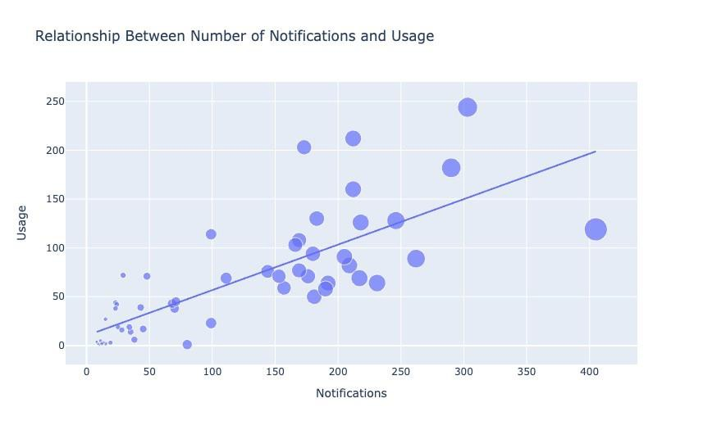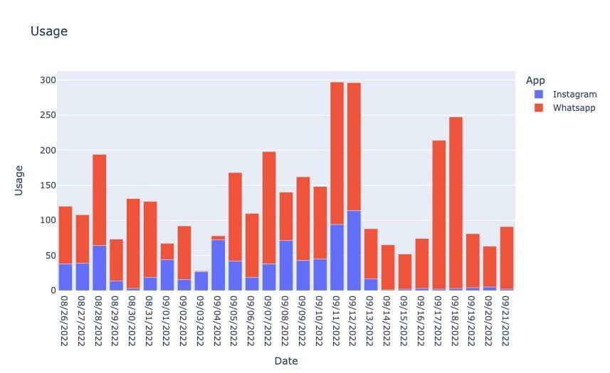

**Output**

**THANK YOU**